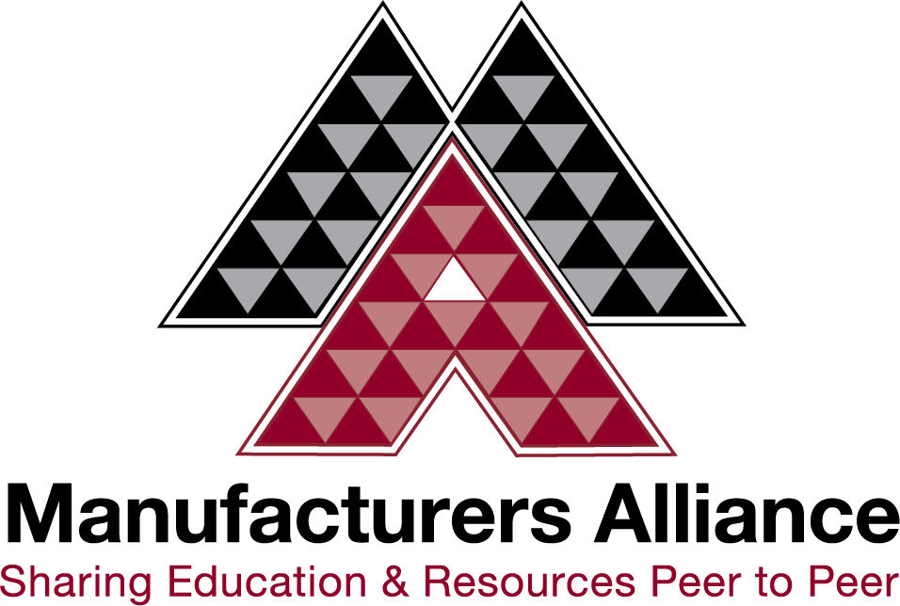

MANUFACTURER OF THE YEAR NOMINATION FORM

The purpose of the Manufacturer of the Year awards is to recognize companies committed to implementing and sharing continuous improvement best practices with fellow manufacturers in the community.

Nominees are typically several years into their Lean journey and actively involved in educating and training all associates. These firms embrace the spirit of cooperation and business community involvement with an abundance mindset and mentality.

This is a prestigious honor conducted in a formal yet open gala. Previous winners report significant boosts to their brand, impact on sales, and workforce recruiting.

Each year, an Award is presented to a single company in each of three categories:
- Companies with fewer than 100 employees (Small)
- Companies with 100 – 400 employees (Medium)
- Companies with +400 employees (Large)

Nomination Deadline & Instructions
You may nominate your own company or any another manufacturer.
- Deadline: May 21st, 2023

Awards Ceremony Date: September 26th, 2023

Complete the nomination form and return to Megan Dawson at megand@mfrall.com. Contact us with any questions via email or phone at 763-332-2762
Nominations are reviewed by a committee comprised of Board members of the Manufacturers Alliance, staff, and other industry leaders selected through convenience sampling. Awards may not be transferred to any other company or division within a company. Awards are open to manufacturers only and those with operations in Minnesota, Wisconsin, and Iowa.

Nomination Form – Base Information
Manufacturing Company Information
Company Name:
Address:
City:
Zip Code:
State:
Products:

# of employees:
Website:

Manufacturing Company Official(s)
Title:
Name:
Email:
Phone:
Email:
Phone:
Title:
Name:

Nominated by
Your Name:
Company:
Phone:
Email:

Criteria for Nomination:
Award winners are selected based on their demonstration of implementing and sharing continuous improvement best practices with fellow manufacturers in the community. Examples of sharing continuous improvement best practices include:
- Presenting at seminars, webinars, and non-mandatory employee training
- Providing plant tours and video tours for peers and community members
- Publishing or contributing to newsletters, blogs or Podcasts
- Teaching within a manufacturing company or for a local college or association
- NEW - Peer recommendations from outside your company exemplifying the positive impact of any of the above items
Each of the winning companies is requested to host a tour of their facility for a limited number of participants following the conference. The Manufacturers Alliance will assist with coordinating the logistics of the tour.

Nomination Form – Essay Portion
Nominated Company Name:
Describe how the nominated manufacturing firm has met the criteria outlined above. Please provide specific examples and other information supporting the nomination. (600 words maximum)

