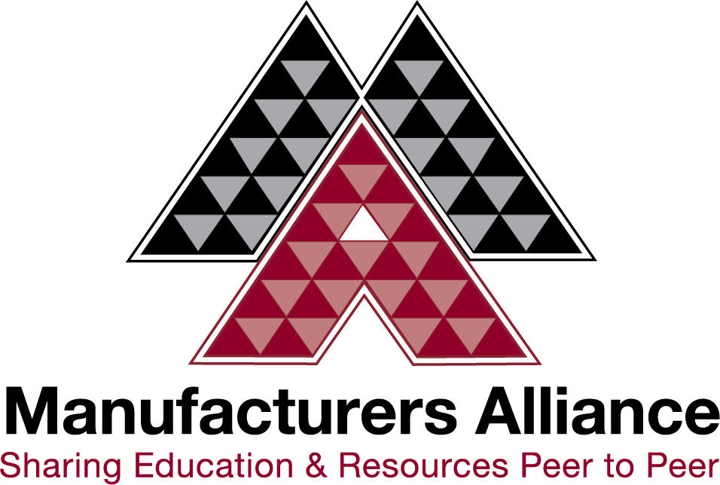

Manufacturer of the Year Nomination Form

The purpose of the Manufacturer of the Year awards is to recognize companies committed to continuous improvement and sharing best practices within the manufacturing community. Nominees are typically several years into their Lean journey and actively involved in education and training of all associates. These firms also embrace the spirit of cooperation and business community involvement.

This is a prestigious honor conducted in a formal yet open ceremony. Previous winners report significant boosts of their brand image and impact on sales and workforce recruiting.

Each year, an Award is presented for each of three categories:
- Companies with fewer than 100 employees (Small)
- Companies with 100 – 400 employees (Medium)
- Companies with +400 employees (Large)

Nomination Instructions
You may nominate your own company or any another manufacturer.

Awards Ceremony Date: Tuesday, September 27th, 2022

Complete the nomination information form and return to Sue Moldenhauer at suem@mfrall.com. Please contact us any questions via email or phone at 763-332-2762 or 763-533-8239.
Nominations are reviewed by a committee comprised of past winners, Board members of the Manufacturers Alliance, and other industry leaders selected through convenience sampling. Awards may not be transferred to any other company or Division within a company. Awards are open to manufacturers only and those with operations in Minnesota, western Wisconsin, and northern Iowa trade areas. A list of nominees and winners will be published by the Manufacturers Alliance. All awards are final.

Nomination Form – Base Information
Manufacturing Company Information
Company Name:
Address:
City:
Zip Code:
State:
Products:

# of employees:
Website:

Manufacturing Company Official(s)
Title:
Name:
Email:
Phone:
Email:
Phone:
Title:
Name:

Nominated by
Your Name:
Company:
Phone:
Email:

Criteria for Nomination:
Award winners are selected based on peer recognition and demonstration of sharing continuous improvement experiences that contribute to the strength of the local manufacturing community. Examples of participation and sharing experiences include the following activities:
- Manufacturing related educational seminars and non-mandatory employee training
- Plant tours and video tours for peers and community members
- Showcasing company for peer groups and encouraging benchmarking
- Publishing articles and posts addressing best practices
- Leadership or teaching in manufacturing organizations
- Sponsoring and conducting peer mentoring programs
- NEW - Peer recommendations from outside your company exemplifying the positive impact of any of the above items
Each of the winning companies is requested host a tour of their facility for a limited number of participants following the awards ceremony and conference. The Manufacturers Alliance will assist with coordinating the logistics of the tour.
Nomination Form – Essay Portion
Nominated Company Name:
Please describe how the nominated manufacturing firm has met the criteria outlined above. Please provide specific examples and any other relevant information supporting the nomination for Manufacturer of the Year Award. (600 words maximum)

