The Wastes | Definition | Examples | Observations
Transportation  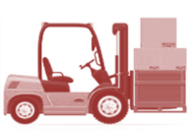 | Movement of product from place to place | - Moving parts in and out of storage  - Moving material from one workstation to another  - Moving parts in and out of quality inspection | 1.  2.
Inventories  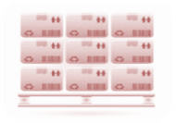 | Idle product. Material not being currently processed | - Raw materials  - Work in process  - Finished goods  - Consumable supplies  - Purchased components  - Maintenance supplies | 1.  2.
Motion | Movement of people, information, or equipment not necessary to produce the product | - Searching for parts, tools, prints  - Sorting through materials  - Reaching for tools  - Lifting boxes of parts  - Walking between machines | 1.  2.
Waiting  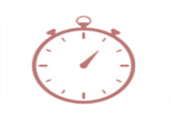 | Any time the product is not able to move immediately to the next process | - Waiting for parts, prints, or information  - Waiting for inspection  - Waiting for machines  - Waiting for machine repair | 1.  2.
Overproduction  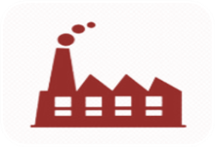 | Producing more than needed or before it is needed | - Producing to forecasts  - Producing to avoid set-ups  - Batch process  - More than standard WIP  - Building ahead of schedule | 1.  2.
Overprocessing | More work done or higher quality than customer requires | - Multiple cleaning or handling  - Paperwork  - Over-tight tolerances  - Awkward tool or part design  - Multiple copies or approvals | 1.  2.
Defects  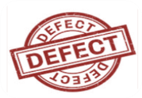 | Work that contains errors, rework, mistakes or is missing necessary items | - Scrap  - Rework  - Correction  - Field failure  - Missing parts | 1.  2.
Skill  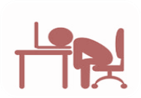 | Not fully utilizing the talents and knowledge of employees | - Boring/tedious work  - Not involved in decisions  - No training or advancement | 1.  2.

